Project Design Phase
Solution Architecture

Date | 25 March 2026
Team ID | 69bf817ef58a227701cd8174
Project Name | Smart Library Request Workflow in ServiceNow
Maximum Marks | 4 Marks

Solution Architecture Overview
The Smart Library Request Workflow is designed to automate library operations, improve efficiency, and provide real-time transparency for both students and library staff. The solution bridges the gap between manual library processes and modern digital workflow automation using ServiceNow as the primary platform.
Goals of the Solution Architecture:
- Identify the optimal technological solution for library request management.
- Describe the system structure, components, and data flow for stakeholders.
- Define features, modules, and solution requirements for development.
- Provide technical specifications for implementation, scalability, and integration.

Architecture Components & Data Flow
- User Layer
  - Users (students/faculty) interact with the system via web portal or mobile browser.
  - Users submit requests, track status, and receive notifications.
- Application / Workflow Layer
  - ServiceNow Flow Designer manages request workflows, approvals, and notifications.
  - Business Rules & Scripted Actions automate decision-making, approvals, and alerts.
- Integration Layer
  - External APIs handle authentication (Gmail OAuth, LinkedIn OAuth).
  - Email notifications and push notifications are integrated via ServiceNow Notification Engine.
- Database Layer
  - ServiceNow Cloud Database stores user profiles, request data, book inventory, and logs.
  - Ensures data consistency, security, and scalability.

- Reporting & Analytics Layer
  - Admin dashboards provide insights on request trends, overdue books, and usage patterns.
  - Optional predictive recommendations for book suggestions based on user history.
- Security Layer
  - Role-based access control (RBAC) ensures students and librarians access only relevant data.
  - Data encrypted at rest and in transit (HTTPS, SHA-256).

Data Flow Description
Step-by-Step Flow:
- User logs in via ServiceNow portal (or Gmail/LinkedIn OAuth).
- User submits a book request form → request enters workflow engine.
- Workflow engine triggers approval process for librarian.
- Librarian approves/rejects → system sends automated notification to user.
- Approved requests update database and reporting dashboards.
- Reminders sent for overdue books → analytics report updated automatically.

Proposed Architecture Diagram
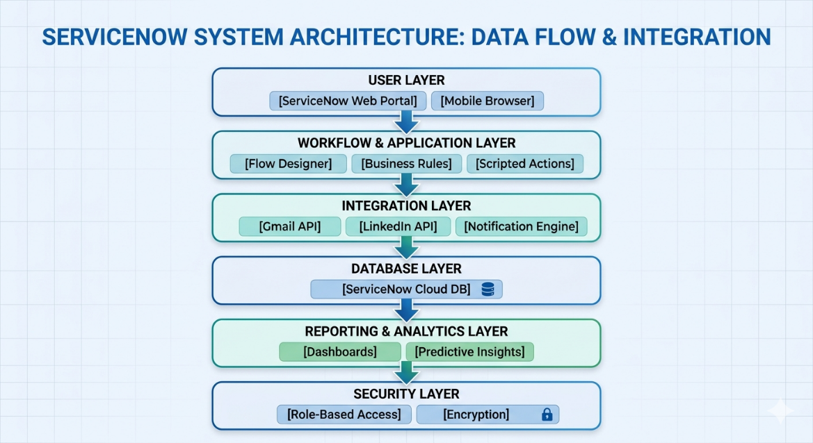

Reference Example: AWS Voice Patient Diary Architecture

